Jing Wang Lab2 G25239885

1. Open the CG lab2.xcodeproj.
2. Please run the main.cpp of project CG lab2
3. copy the house.d file to the root debug folder.
4. Run the project again and you can get the picture as below.

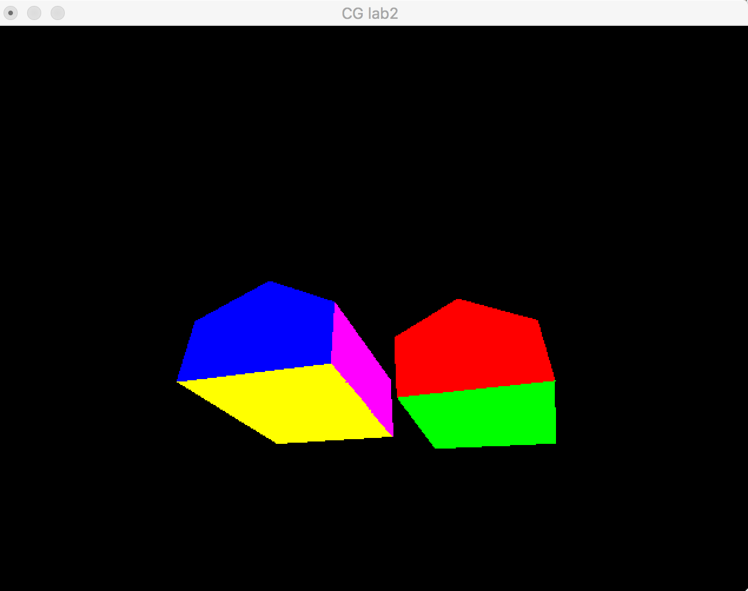

If you change the C or P coordinate , the picture will change.

For example,

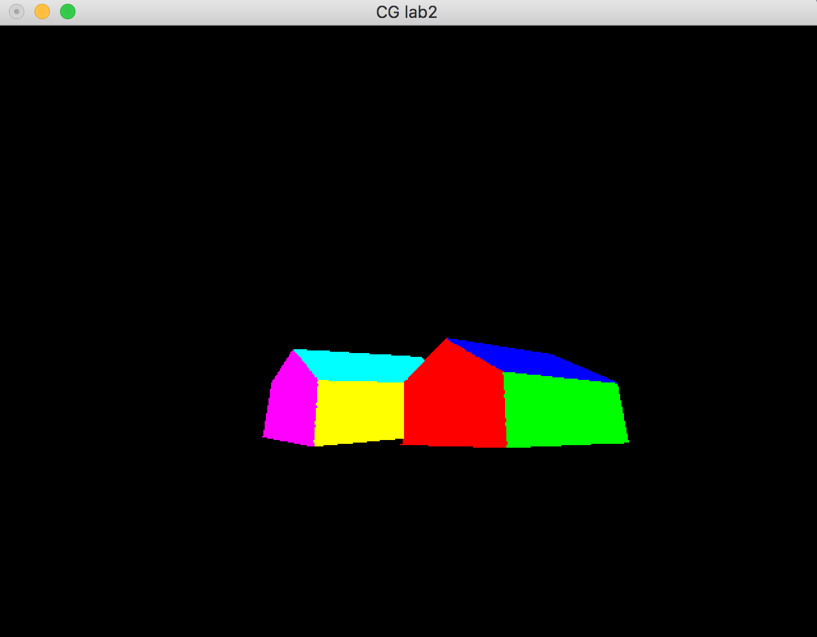

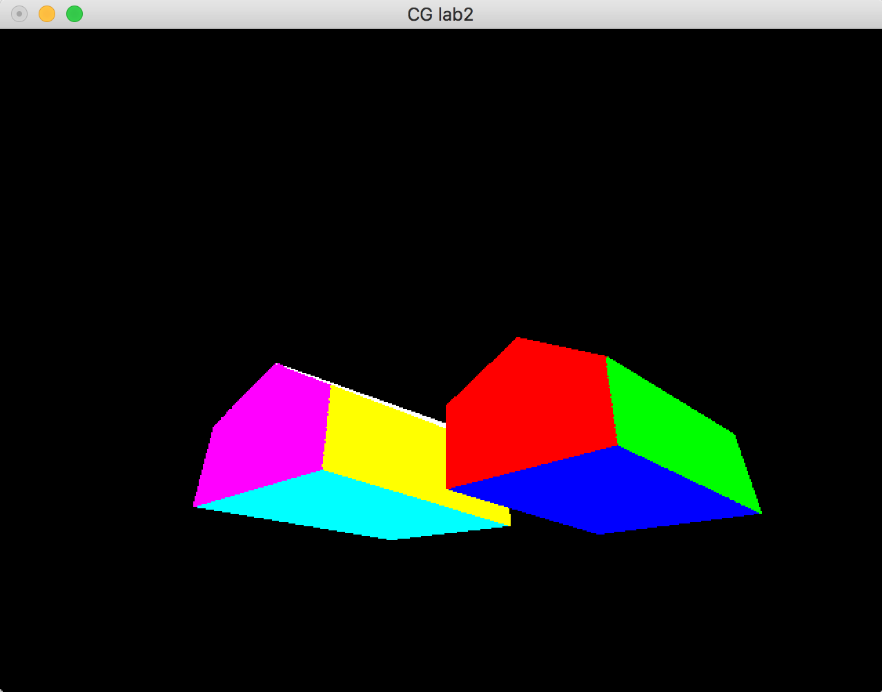

Thanks.